FINAL TASK 1

Rakhmetulla Timur

SWD-1803

*[P.S. Background image is static.]*

Home Page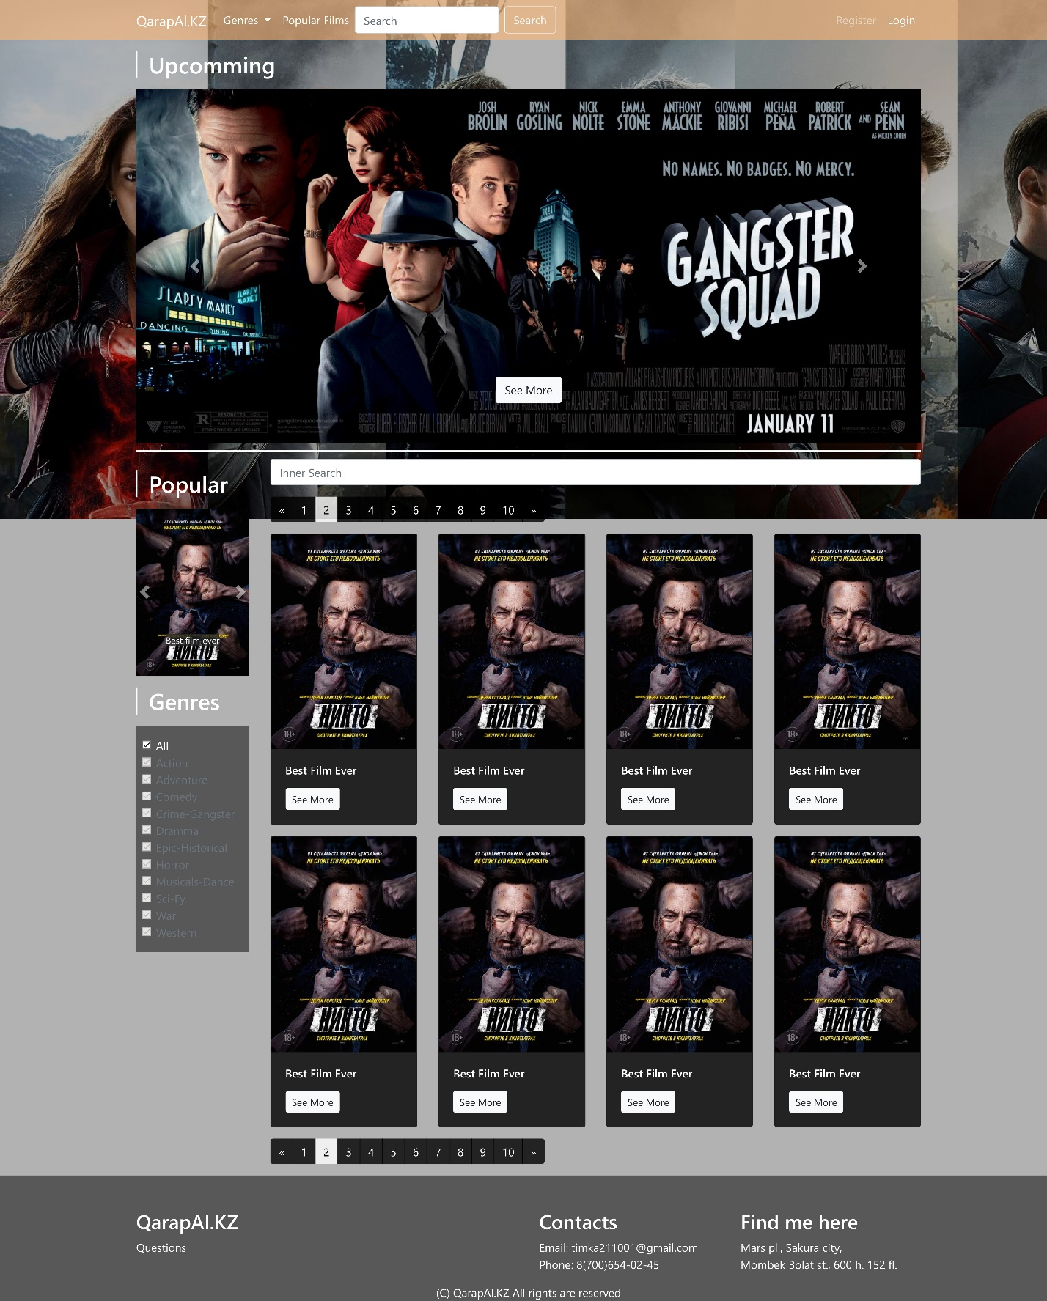

Register Page

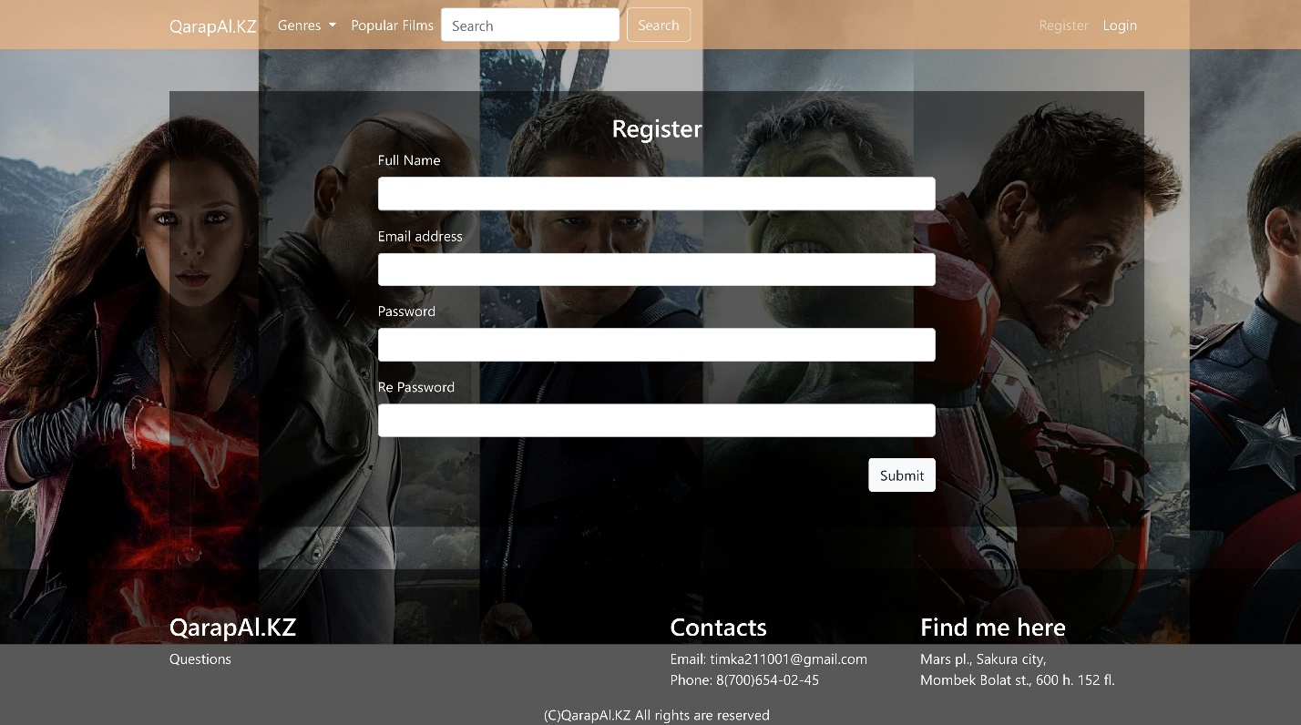

Login Page

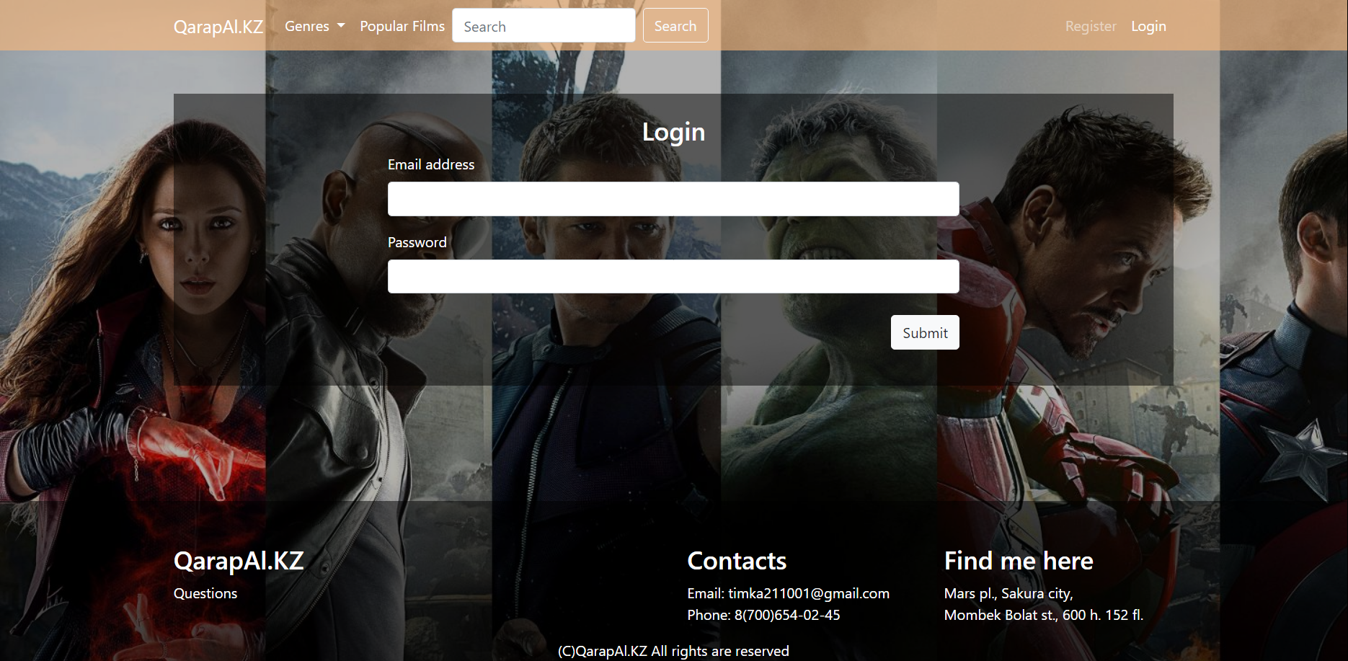

Profile Page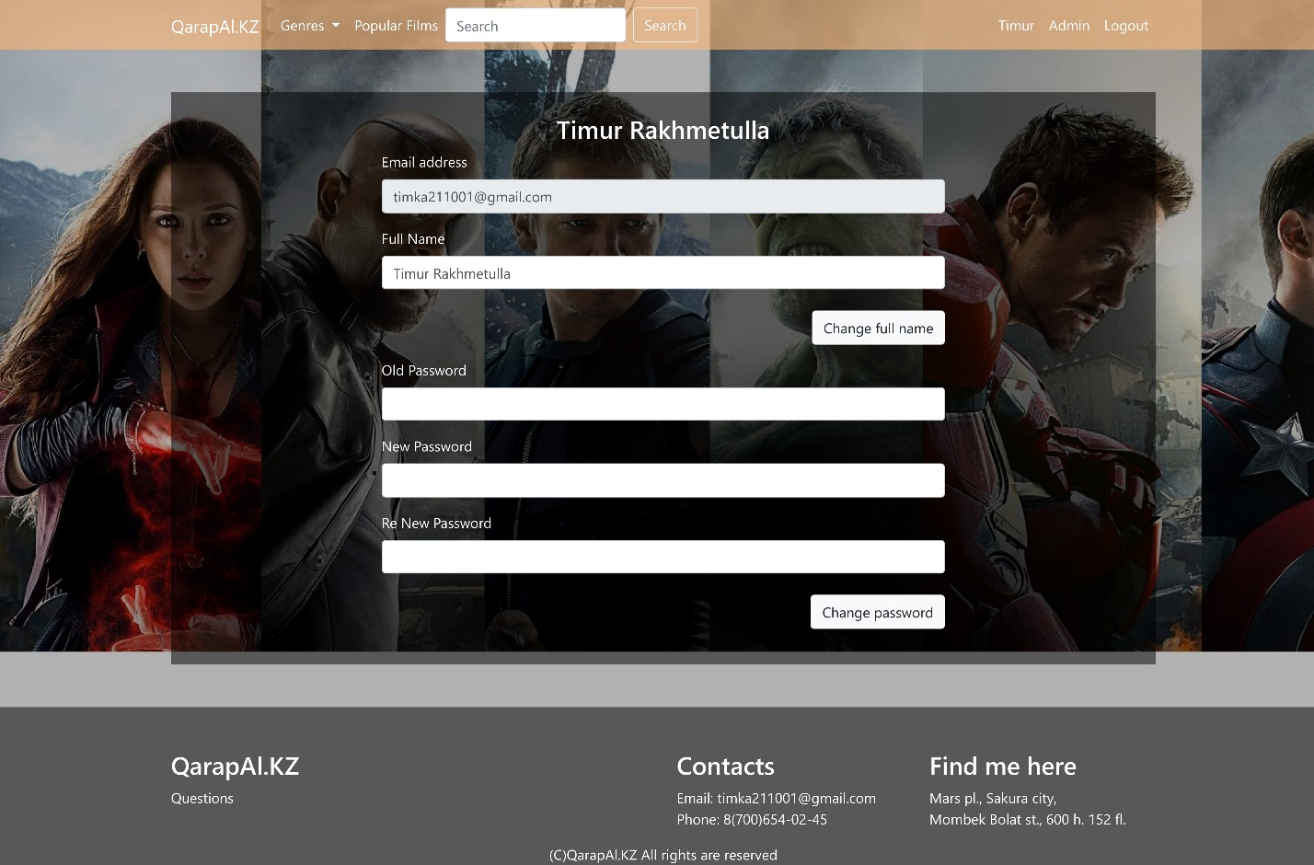

Admin Page – Manage User

